**A**

**Project Dissertation Report on**

**“ Leaf disease Detection ”**

SUBMITTED TO THE PUNYASHLOK AHILYADEVI HOLKAR SOLAPUR UNIVERSITY, SOLAPUR IN PARTIAL FULFILLMENT OF THE REQUIREMENTS FOR THE AWARD OF

### BACHELOR OF TECHNOLOGY DEGREE IN COMPUTER SCIENCE AND ENGINEERING

### SUBMITTED BY

### Mr. Mustafa Masuldar Roll No. 16

### Ms. Sakshi Deshmukh Roll No. 17

### Ms. Pooja Pawar Roll No. 18

### Ms. Nandini Madre Roll No. 19

### Ms. Maleka Iram Muchale Roll No. 20

### UNDER THE GUIDANCE OF

**Prof. Shailaja S. Shelke**



### DEPARTMENT OF COMPUTER SCIENCE & ENGINEERING

### N. B. NAVALE SINHGAD COLLEGE OF ENGINEERING, SOLAPUR - 413 255

### 2023-24

### AFFILIATED TO

### PUNYASHLOK AHILYADEVI HOLKAR SOLAPUR UNIVERSITY, SOLAPUR

**CERTIFICATE**

This is to certify that the dissertation report entitled

|  |  |  |  |  |
| --- | --- | --- | --- | --- |
| **“ Leaf Disease Detection ”**  submitted by | | | | |
| **Mr.** | **Mustafa Masuldar** |  | **Roll No.** | **16** |
| **Ms.** | **Sakshi Deshmukh** |  | **Roll No.** | **17** |
| **Ms.** | **Pooja Pawar** |  | **Roll No.** | **18** |
| **Ms.** | **Nandini Madre** |  | **Roll No.** | **19** |
| **Ms.** | **Maleka Iram Muchale** |  | **Roll No.** | **20** |

is a bonafide work carried out by above students under the supervision of Prof. Shailaja S. Shelke and it is submitted towards the fulfillment of the requirement of Punyashlok Ahilyadevi Holkar Solapur University, Solapur for the award of the degree of Bachelor in Technology (Computer Science and Engineering) during academic year 2023-24.

### (Prof. Shailaja S. Shelke) (Dr.Dattatray P.Gandhmal) Project Guide Head of Department

### Department of CSE Department of CSE

### (Dr. Shankar. D. Navale) Principal,

### N. B. Navale Sinhgad College of Engineering, Solapur.

### Place: Solapur

**CERTIFICATE**

This is to certify that the dissertation report entitled

**“ Leaf Disease Detection ”**

submitted by

### Mr. Mustafa Masuldar Seat No. 216402

### Ms. Sakshi Deshmukh Seat No. 216398

### Ms. Pooja Pawar Seat No. 216394

### Ms. Nandini Madre Seat No. 216526

### Ms. Maleka Iram Muchale Seat No. 216614

is a bonafide work carried out by above student under the supervision of Prof. Shailaja S. Shelke and it is submitted towards the fulfillment of the requirement of Punyashlok Ahilyadevi Holkar Solapur University, Solapur for the award of the degree of Bachelor in Technology (Computer Science and Engineering) during academic year 2023-24.

### Internal Examiner Name & Sign:

### External Examiner Name & Sign :

### Place : Solapur

**DECLARATION**

We hereby declare that the work embodied in this Project Dissertation Report Entitled **“Leaf Disease Detection”** is carried out by us in partial fulfillment of the degree Bachelor in Technology (Computer Science and Engineering) from N. B. Navale Sinhgad College of Engineering, Solapur and we have not submitted the same to any other University Institute for the award of any other degree.

### Mr. Mustafa Masuldar

### Ms. Sakshi Deshmukh

### Ms. Pooja Pawar

### Ms. Nandini Madre

### Ms. Maleka Iram Muchale

### Place: Solapur Date : / /

**ACKNOWLEDGEMENT**

We feel profound happiness in forwarding this dissertation report as an image of sincere efforts. Our sincere thanks to respected **Prof. Shailaja S. Shelke**, our project guide, for providing healthy environment and facilities in the department. He allowed us to raise our concern and worked to solve it by extending his co-operation time to time. Our Project Guide has been a constant source of inspiration and helping us for selecting the topic, contents, giving valuable suggestions to complete project, preparation of project dissertation report and presentation.

We give our special thanks to respected Head of Department **Dr. Dattatray P.**

**Gandhmal** for their constant interest and encouragement throughout the completion of

our project.

Goal makes us to do work. Vision is more important than goal which makes us to

do work in the best way to make work equally the best. Thanks to our respected

Principal, **Dr. Shankar. D. Navale** for his support and vision.

We express our deep gratitude to all staff members who lend me their valuable support and

cooperation to enable me to complete my project successfully.

We also thankful to all friends for their extended support and valuable guidance.

### Mr. Mustafa Masuldar

### Ms. Sakshi Deshmukh

### Ms. Pooja Pawar

### Ms. Nandini Madre

### Ms. Maleka Iram Muchale

**ABSTRACT**

One of the major sources of yield in India is the production of crops. It is of enhancing the technological advancement in the fields related to crop productivity. Here farmers cultivate a maximum diversity of plants and crops. More studies are built with the important domain of qualitative and efficient farming is concentrated on enhancing the yield and food crop productivity at a minimum time with a greater outcome.

The detection of plant disease by human visualization is a more difficult task and at the same time, less efficient, and it’s done with a limited set of leaf images and takes more time. Whereas the automatic identification technique will take less effort and time and a more accurate program. Here we use image processing to detect the diseases. We can put the image into a system and a computer can perform various phases for identification and detect the related classes to which that image belongs.

This work aims to make a leaf recognition technique based on the specific characteristics derived from images. First of All, here import the packages like OpenCV, NumPy, tqdm, TensorFlow, matploatlib, etc., and define the functions for label images, and load training data. We classify the images into four categories depending on the code name of plant diseases.

For training, phase loads the variety of images and it resizes with a resolution of 50*50. Then images and corresponding labels are appended to the list. The above steps are used for testing the data. For classification here, we use the CNN algorithm. It consists of several layers for efficient implementation. In each step, convolutional layer build and pooling are added.

Finally, the regression layer is added to get the output. Another important parameter is learning rate (LR) which consists of how the speed at which learning the model. Here 1.e-3 set as LR. After the model building, load the data in the model. Here we use the variable consisting of a model name that represents healthy or diseased. Then save the model on the folder to this variable name and put the data to this model and detect it.

Common diseases like viral, bacterial, fungal infections can be difficult to distinguish, and these symptoms can be represented in the difference in color, function, and shape in which plant responds to the pathogen. Smaller datasets are less efficient and affect the model performance. Training a large set of data can not only reduce over fitting but can enhance a model’s overall performance.

The quality and type of training dataset massively impact the model capabilities. The training data contains noise the classifier’s accuracy becomes dependent on this composition. This topic of early detection is explored due to a limited number of datasets, and it consists of less accuracy and detection. This system avoids the gathering of more leaf inputs for studying them in the laboratory because preexisting images and datasets are taken and identify the plant diseases.it imparts a feasible functioning approach that can use not be costly and complex. It works by using CNN to detecting the leaf is healthy or diseased and if it is a disease it identifies the diseases like fungi, viruses, bacteria, black spots, powdery mildew, downy mildew, blight, canker, etc. and also provides remedies for recoverability of these diseases.

### Dissertation Outline

The dissertation is organized chronologically in terms of the objectives accomplished.

**Chapter One** gives information about leaf diease detection along with scope, objectives and needs.

**Chapter Two** gives literature review on the relevant areas required for the cur- rent research which contains approaches considered for machine learning and web portal performance.

**Chapter Three** gives complete design of the system along with system architecture, Analysis models, UML diagrams.

**Chapter Four** gives overview on which type of system we need to run our application.

**Chapter Five** gives technical aspects such as languages, application modules, technological discussions etc.

**Chapter Six** gives approaches of testing and different test cases to test application.

**Chapter Seven** gives result and its discussions.

**Chapter Eight** gives overview on future scope and conclusion of application and result.

**A Appendix** lists of abbreviation used in the dissertation.

**B Appendix** lists of publication done on current work.

**C References** lists the bibliography for the system.

**Contents**

|  |  |  |  |  |
| --- | --- | --- | --- | --- |
| **1** | **INTRODUCTION** | | | **1** |
|  |  | | |  |
|  | 1.1 Introduction to Project . . . . . . . . . . . . . . . . . . . . . . . . . . | | | 1 |
|  | 1.2 Problem Statement . . . . . . . . . . . . . . . . . . . . . . . . . . . . | | | 1 |
|  | 1.3 Scope and Objectives . . . . . . . . . . . . . . . . . . . . . . . . . . | | | 2 |
|  | 1.3.1 Scope . . . . . . . . . . . . . . . . . . . . . . . . . . . . . . . . | | | 2 |
|  | 1.3.2 Objectives . . . . . . . . . . . . . . . . . . . . . . . . . . . . . . | | | 2 |
|  |
|  | 1.5 Unique Features of the System . . . . . . . . . . . . . . . . . . . . . . | | | 4 |
|  | 1.6 Applications . . . . . . . . . . . . . . . . . . . . . . . . . . . . . . . | | | 5 |
| **2** | **LITERATURE REVIEW** | | | **6** |
|  | 2.1 Literature Review. . . . . . . . . . . . . . . . . . . . . . . . . . . . | | | 6 |
|  | 2.2 Existing Systems . . . . . . . . . . . . . . . . . . . . . . . . . . . . | | | 8 |
| **3** | **SYSTEM DESIGN** | | | **10** |
|  | 3.1 System Architecture . . . . . . . . . . . . . . . . . . . . . . . . . . . | | | 10 |
|  | 3.2 Analysis model . . . . . . . . . . . . . . . . . . . . . . . . . . . . . . | | | 13 |
|  | | 3.2.1 | ER Diagram . . . . . . . . . . . . . . . . . . . . . . . . . . . . . | 13 |

1. REQUIREMENT SPECIFICATION 26
   1. Hardware Requirements 14
   2. Software Requirements 14
2. IMPLEMENTATION 15
   1. Technologies used for Implementation 15
      1. Introduction to Languages 15
      2. Integrated Development Environments 16
      3. Technologies Used 17
      4. Working 18

|  |  |  |  |
| --- | --- | --- | --- |
| **6** | **Testing** | **22** |  |
|  | 6.1 Test Plan . . . . . . . . . . . . . . . . . . . . . . . . . . . . . . . . . . | 22 |  |
|  | 6.2 Functional Testing . . . . . . . . . . . . . . . . . . . . . . . . . . . . . | 24 |  |
|  | 6.3 Non-Functional Testing . . . . . . . . . . . . . . . . . . . . . . . . . .  . | 25 |  |
| **7** | **CONCLUSION AND FUTURE SCOPE** | **27** |  |
|  | 7.1 Conclusion . . . . . . . . . . . . . . . . . . . . . . . . . . . . . . . . . . | 27 |  |
|  | 7.2 Future Scope . . . . . . . . . . . . . . . . . . . . . . . . . . . . . . . . | 27 |  |
| **A** | **Appendix : List of Abbreviations** | **28** |  |
| **B** | **Appendix : List of References** | **29** |  |

### Chapter 1

### INTRODUCTION

**Introduction to Project :**

The major reason for minimizing crop productivity is various diseases in plants. To eliminate the disease-induced losses in plants during growth as well as to increase crop productivity, former disease detection and prevention on the crop are the most challenging factors.

Thus, it is a suitable decision that can be taken by the farmers or villagers to avoid further losses. The project works on the technique of image processing which identifies the various diseases in plants.

Here we use an efficient convolutional neural network algorithm (CNN) algorithm which can detect the type of diseases in various leaves.

Our proposed paper includes implementation steps like datasets gathering, training, segmentation, feature extraction, testing, and classification, using CNN to classify the leaves which are diseased or healthy based on data.

This work implemented in giving the input leaf in real-time from the source of Google or dataset is trained under the system helps in disease detection and represents remedies for overcoming the deficiency. After the validation step, the project provides an accuracy of 99.5%.

**Problem Statement:**

Create a web application that makes use of CNN to build a model by making use of the images of the plant leaf, so as to detect the disease and suggest the appropriate remedies to counteract the disease. If the leaf is found unhealthy i.e., diseased, our project tells what type of disease that the leaf is infected with. Our main objective is to classify whether the leaf is having Bacterial spot, Late Blight, Yellow Curl Leaf virus using machine learning algorithm like Logistic Regression.

**Scope and Objectives:**

**Scope:**

Leaf disease detection holds significant scope and relevance across agriculture, plant pathology, and technology. Early detection is crucial for preventing the spread of pathogens and minimizing crop damage. Precision agriculture benefits from technologies that enable targeted treatments, reducing the reliance on pesticides and optimizing resource usage.

Integration of remote sensing, drones, and sensor networks facilitates efficient monitoring of agricultural areas, while data analytics and machine learning play a pivotal role in analyzing visual symptoms and predicting disease outbreaks.

This field also contributes to research and development by identifying pathogens and developing resistant crop varieties. Educational initiatives and information dissemination empower farmers, and the global impact addresses food security and economic implications. Collaboration among diverse experts and the implementation of monitoring systems further enhance the comprehensive scope of leaf disease detection, aiming for sustainable and effective solutions in agriculture

**Objectives**

Detection of plant leaves diseases and pests needs experiences and experts. So, we like to equip the young generation of inexperienced farmers with a web application that can help them in their farms to detect the diseases in their plants and provide them with appropriate remedies according to the disease detected.

**Early Disease Detection:**

* **Prevention:** Early detection of leaf diseases can help prevent the spread of pathogens and minimize crop damage.
* **Precision Agriculture:** Implementing technologies for early detection allows farmers to apply treatments only where and when needed, reducing the use of pesticides and optimizing resource usage.
* **Decision Support Systems:** Leaf disease detection can be integrated into decision support systems that provide farmers with real-time information on crop health, enabling better management decisions.
* **Yield Optimization:** By identifying and managing leaf diseases promptly, farmers can optimize crop yield and quality.
* **Technology Integration:**
* **Remote Sensing:** Satellite imagery, drones, and other remote sensing technologies can be employed to monitor large agricultural areas efficiently.
* **IoT and Sensor Networks:** Deployment of sensors in the field can provide continuous monitoring, enabling early detection and data-driven decision-making.
* **Data Analytics and Machine Learning:**
* **Image Analysis:** Use of computer vision and image processing techniques to analyze visual symptoms of diseases on leaves.
* **Machine Learning Models:** Training models on historical and real-time data to identify patterns and predict disease outbreaks.
* **Research and Development:**
* **Pathogen Identification:** Understanding the characteristics of pathogens causing leaf diseases for developing targeted treatments.
* **Resistant Crop Varieties:** Developing crop varieties resistant to common leaf diseases through genetic modification or selective breeding.
* **Education and Outreach:**
* **Training Programs:** Educating farmers and agricultural professionals on the identification and management of leaf diseases.
* **Information Dissemination:** Providing accessible information through mobile Apps , websites, and other platforms to empower farmers with knowledge.
* **Global Impact:**
* **Food Security:** Addressing leaf diseases contributes to global food security by ensuring stable crop production.
* **Economic Impact**: Minimizing crop losses due to diseases has positive economic implications for farmers and the agricultural sector.
* **Collaboration:**
* **Multi-disciplinary Approach:** Involving experts from agriculture, biology, technology, and data science for comprehensive solutions.
* **Public-Private Partnerships:** Collaboration between governments, research institutions, and private companies can drive innovation and scalability
* **Public-Private Partnerships:** Collaboration between governments, research institutions, and private companies can drive innovation and scalability.
* **Epidemiological Studies:** Monitoring the spread of diseases over time to understand their patterns and dynamics.

**Unique Features of the System**

The leaf disease detection system boasts several unique features that set it apart and contribute to its effectiveness in agriculture and plant health management.

**Advanced Image Analysis:**

The system employs cutting-edge computer vision and image processing techniques for precise and accurate identification of visual symptoms associated with leaf diseases. This advanced analysis ensures reliable and early detection of potential issues.

**Machine Learning Algorithms:**

Utilizing machine learning models, the system continually learns and improves its ability to identify and classify various leaf diseases. This adaptive nature enhances the accuracy of detection and allows for the incorporation of new information and patterns over time.

**Integration of Remote Sensing Technologies:**

The system seamlessly integrates with remote sensing technologies, such as satellite imagery and drones, providing a comprehensive and real-time view of agricultural landscapes. This integration allows for large-scale monitoring and timely intervention.

**User-Friendly Interfaces:**

The system features user-friendly interfaces accessible through various platforms, including mobile applications and web interfaces. This ensures that farmers, regardless of their technical expertise, can easily navigate and utilize the system to make informed decisions about crop management.

**Customizable Decision Support Systems:**

Tailoring recommendations to specific crops, regions, and environmental conditions, the system offers highly customizable decision support. This adaptability enhances its applicability across diverse agricultural scenarios.

**Predictive Analytics:**

Through the application of predictive analytics, the system not only identifies current disease conditions but also anticipates potential outbreaks. This proactive approach allows farmers to implement preventive measures and minimize the impact on crop yields.

**Security Measures:**

The system prioritizes data security, ensuring the confidentiality and integrity of sensitive agricultural information. Robust security measures are implemented to protect against unauthorized access and data breaches.

**Scalability and Interoperability:**

Designed for scalability, the system can adapt to varying farm sizes and types. It is also built with interoperability in mind, allowing seamless integration with existing agricultural management systems and practices.

**Applications**

The leaf disease detection system offers early identification of crop diseases, enabling precision agriculture and informed decision-making. It integrates with remote sensing, drones, and IoT sensors for comprehensive monitoring. Applications include crop management, decision support, research, education, and contributing to global food security. The system's adaptability, security measures, and scalability make it a versatile tool for sustainable and efficient plant health management

# Chapter 2

# LITERATURE REVIEW

* In the study titled "Smart Farming: Pomegranate Disease Detection Using Image Processing (2015)," the authors developed a web-based tool for identifying fruit diseases, specifically focusing on pomegranates. The tool employs image processing techniques with feature extraction based on color, morphology, and color coherence vector (CCV). Clustering is performed using the k-means algorithm, and Support Vector Machine (SVM) is utilized for classification into infected or non-infected categories. The study achieved an accuracy of 82% in identifying pomegranate diseases.
* "Leaf Disease Detection and Recommendation of Pesticides using Convolution Neural Network (2018)" addresses crop production challenges in India. The proposed system involves pre-processing and feature extraction of leaf images from plant village datasets, followed by classification using Convolutional Neural Network (CNN) and recommendation of pesticides. The model employs different layers of CNN, with the highest accuracy of 95.05% achieved for a 5-layer model in 15 epochs. The system integrates an Android application with Java Web Services and Deep Learning.
* "An Artificial Intelligence and Cloud-Based Collaborative Platform for Plant Disease Identification, Tracking, and Forecasting for Farmers (2018)" presents an automated solution for precise and instant diagnosis of crop diseases. This low-cost system aids farmers in quick decision-making for disease control measures. The platform utilizes artificial intelligence and cloud-based technologies to identify, track, and forecast plant diseases, contributing to efficient farming practices.
* The study on "CNN-based Leaf Disease Identification and Remedy Recommendation System (2019)" focuses on plant disease detection using image processing. The approach employs an open dataset with 5000 images of healthy and unhealthy plants, utilizing convolutional neural network (CNN) and semi-supervised techniques for classification. The CNN is trained in a natural environment, achieving a notable classification ability of 99.32%, highlighting the effectiveness of CNN in extracting crucial features for plant disease identification.
* These studies collectively emphasize the significance of advanced technologies such as image processing, convolutional neural networks, and artificial intelligence in addressing challenges related to plant disease detection, classification, and recommendation of remedies. The integration of these technologies showcases promising results in enhancing agricultural practices and supporting farmers in making informed decisions for disease control and crop management.
  1. **Literature Review**

A literature review typically involves a comprehensive examination and summary of existing research and scholarly works related to a specific topic. For a leaf disease detection system, a literature review might encompass studies, articles, and publications covering various aspects of plant pathology, agricultural technology, and related fields. Below is a concise overview of potential literature review themes:

**Leaf Disease Detection Technologies:**

Explore literature on the latest technologies used in detecting leaf diseases, including computer vision, machine learning, and remote sensing. Examine the strengths and limitations of each approach.

**IoT and Sensor Networks in Agriculture**:

Investigate how Internet of Things (IoT) devices and sensor networks contribute to real-time monitoring of crops, focusing on their application in detecting and managing leaf diseases.

**Image Analysis Techniques:**

Review studies that delve into image analysis techniques for identifying visual symptoms of leaf diseases. Assess the effectiveness of different algorithms and methodologies.

**Machine Learning Applications in Agriculture:**

Examine literature on the application of machine learning models for predicting and diagnosing crop diseases. Consider the types of models used and their performance in real-world scenarios.

**Precision Agriculture and Disease Management:**

Explore how precision agriculture practices, including variable rate technology and site-specific management, are employed in disease management strategies. Highlight successful case studies and best practices.

**Remote Sensing for Crop Health Monitoring:**

Investigate the use of satellite imagery, drones, and other remote sensing technologies for monitoring crop health and disease prevalence. Assess the accuracy and scalability of these approaches.

**Data Analytics for Epidemiological Studies:**

Review literature discussing the role of data analytics in understanding the epidemiology of plant diseases. Examine how data-driven approaches contribute to predicting disease outbreaks.

**Plant Pathology and Pathogen Identification:**

Explore studies in plant pathology that focus on identifying pathogens causing leaf diseases. Consider research on genetic resistance and the development of disease-resistant crop varieties.

**Decision Support Systems in Agriculture:**

Examine the literature on decision support systems for agriculture, particularly those designed to assist farmers in managing and mitigating the impact of leaf diseases.

**Challenges and Future Directions:**

Summarize existing literature discussing the challenges in leaf disease detection and propose potential solutions. Explore emerging trends and future directions in the field.

* 1. **Existing Systems :**

**PlantVillage:**

PlantVillage is an online platform that uses machine learning and artificial intelligence to diagnose plant diseases. It provides a knowledge base, allows users to upload images for disease identification, and offers recommendations for treatment.

**AgroCares Scanner:**

AgroCares offers a portable soil scanner that measures nutrient levels in the soil, providing insights into plant health. This technology helps farmers make informed decisions about fertilization and nutrient management.

**Taranis:**

Taranis is an agriculture intelligence platform that utilizes aerial imagery, satellite data, and machine learning algorithms to monitor crops. It helps in early detection of diseases, pests, and other issues affecting crop health.

**FieldView by Climate Corporation:**

FieldView is a digital agriculture platform that collects and analyzes data from farms. It provides farmers with insights into field variability, including potential issues related to diseases, and assists in making data-driven decisions.

**Plantix:**

Plantix is a mobile app that employs image recognition technology for plant disease diagnosis. Users can take pictures of plant symptoms, and the app provides information about the likely disease along with suggested management practices.

**Ceres Imaging:**

Ceres Imaging uses aerial imagery and analytics to monitor crop health. It can identify stress factors, diseases, and nutrient deficiencies, allowing farmers to address issues before they impact yields.

**GeoVisual Analytics:**

GeoVisual Analytics integrates satellite and drone imagery with machine learning algorithms to assess crop health. It provides farmers with detailed maps highlighting areas with potential diseases, enabling targeted interventions.

**SmartAgro:**

SmartAgro is a precision agriculture system that combines sensor data, satellite imagery, and weather information to provide farmers with real-time insights. It aids in disease detection and supports efficient resource management.

**FarmBeats by Microsoft:**

FarmBeats is an agriculture platform that utilizes IoT sensors, drones, and machine learning to collect and analyze data from farms. It helps farmers monitor crop health, optimize irrigation, and detect diseases.

# Chapter 3

## SYSTEM DESIGN

* 1. **System Architecture**

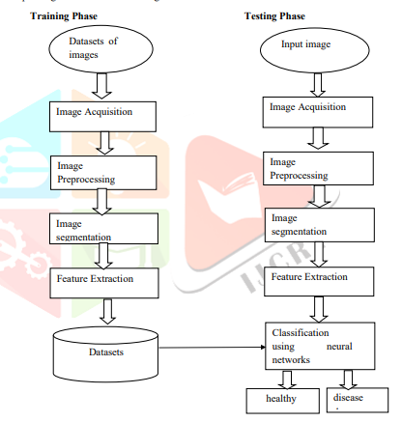

Figure 3.1: System Architecture

This area includes the implementation steps and methods consisting of creating and deploying identification, classification techniques. For classification, here we use efficient convolutional neural networks (CNN) algorithm. Here we have two folders train and test. Training used for building the system on plant leaves and test consists of testing the system and detecting the accuracy of the work. First of All, import the necessary packages like OpenCV, NumPy, TensorFlow, etc. Here defining the first function for label images. The developed model builds with four classes of classification. Next, create a function for loading the training data. Training data load images from our folder then resize it. Here resizes the image with a resolution of 50*50. After resizing append the images and corresponding labels to the list. Testing data build with same as mentioned above. Dataset: This is a set of images for specified purposes. We use a plant leaf dataset and each of them is divided for preprocessing and classification. The Leaf dataset consists of more than 1000 images of various plants. This contains both healthy and diseased leaves. The diseased class includes in name of the specified disease and provides remedies for overcoming the deficiency. Here we train the large dataset and detect the disease present on each leaf.

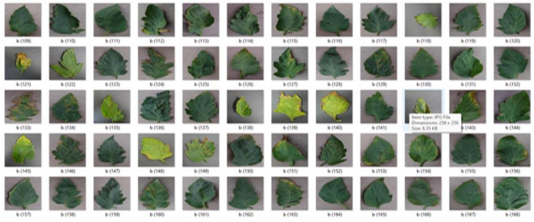

**Image acquisition:** To put the desired leaf image from the dataset or real-time source from Google is also established, the sampled images of the diseased and healthy leaves are gathered and used in training the system for acquisition.

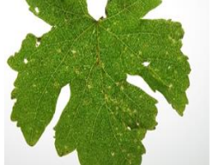

**Image preprocessing:** preprocessing of leaves is bringing all the image sizes to be reduced uniform size like 50*50 resolution. The main motive of this step is to remove the noise or other unwanted objects from the image.

**Segmentation:** segmentation is a phase of image processing it segments the leaves into several parts and derives useful and meaningful information from the data. It derives the leaves based on leaf perimeter, shape, region edge, threshold, feature, and model. There are different types of segmentation techniques are available here we use neural network-based segmentation. **Feature Extraction:** CNN contains various layers which provide feature extraction and further classification of images. The key role of feature extraction in plant disease identification is to learn the features automatically. The basic geometrical features are derived in this step. Feature extracted based on the parameters like diameter, width, leaf area, leaf perimeter, morphological features, shape, texture, rectangular, etc.

**Classification:** classification is a process of placing each of the images under specified classes. The classification is a step in which it compares various values received after the feature extraction, and it classifies the input leaf is diseased or healthy, to establish efficient relation analysts use data. Here, we classify four categories as leaf images. If the resulting status of the leaf is diseased it provides the remedies for removing the deficiency.

**ALGORITHM DESCRIPTION**

* The last step in our processing of the leaf phase is the testing of various images and identifying the diseases. The algorithm used in the classification program is CNN. CNN consists of a complex network chain that extracts the characters in the images and classifies them to get specified results related to the input.
* Neural networks build with many layers like the input layer, convolutional layer, output layer, and fully connected layer. The Convolutional layer can add more layers to it. Firstly, we load the input data and create the convolution layer.
* Each layer consists of an activation function. Together with the convolutional neural network, we add a pooling function. Here five convolutional layers build, with corresponding pooling is added. At the end of each layer take the fully connected layer and give a softmax activation function.
* Finally, the regression layer is used for receiving the result and using the optimizer. Another important parameter is learning rate (LR) which represents the speed at which one learns the model. Here we set the learning rate as 1.e-3. After the model building, load the data in the model.
* Training data convert for x and y. x is the image and y defines the label. We use the variable for the model to represent healthy and unhealthy. Finally, give the data for the model and detect if it is healthy or diseased. CNN algorithm is more efficient for dividing a huge amount of data and it can be described as an efficient machine learning algorithm. As it is building on finding solutions to classification and identification tasks.
* It can be learning characters automatically on the dataset. This algorithm analyzes visual leaves more efficiently. The structures of this algorithm change dramatically. The quality and type of training data collectively impact the capabilities of the model.
* Classifier accuracy depended on the data. Classification is made with the nature .

**ER Diagram**

**Output**: classification of a review into healthy or diseased, it is diseased provides the remedies for overcoming the deficiency.

**Step1:** Start

**Step2:** prepare a database (healthy or diseased)

**Step 3:** preprocessing normalization

**Step4:** Train CNN

**Step5**: real images from Google or dataset

**Step6:** preprocessing

**Step7:** test network

**Step8 Training and Testing Algorithm Input:** providing an image of leaves localization

**Step9:** if the probability of healthy > probability of unhealthy display a healthy leaf, otherwise display a diseased leaf.

**Step10:** go to the fourth step

**Step11:** stop 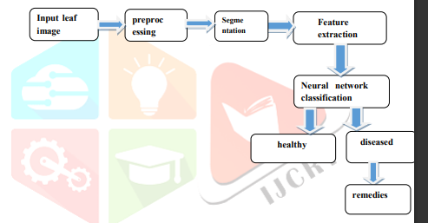

Figure 3.2: Process Diagram

# Chapter 4

# REQUIREMENT SPECIFICATION

# Hardware Requirements

**Personal Computer** Ram: Minimum 1 GB Memory: Minimum 256 GB Processor: Minimum Intel i3

# 

# Software Requirements

Chrome, Mozilla Firefox, Microsoft Edge ,Vs code , Python.

**Chapter 5**

**IMPLEMENTATION**

# Technologies used for Implementation

## Introduction to Languages

### JavaScript

JavaScript is a popular programming language primarily used for building dynamic and interactive web applications. It is supported by all modern web browsers and has gained significant popularity due to its versatility and flexibility. In addition to traditional JavaScript, several frameworks and libraries have been developed to simplify and enhance the development process. Some notable frameworks in the JavaScript ecosystem include React, Express, and Node.js.

### Python

Python is a versatile and widely-used programming language known for its simplicity and readability. It offers a robust ecosystem of libraries and frameworks that facilitate various development tasks. When it comes to web development, Django is a popular Python framework that simplifies building scalable and maintainable web applications. In addition, Python is widely adopted in the field of machine learning (ML) due to its extensive libraries and tools for data analysis and modeling. Let’s explore how Python, Django, and ML work together

* + - 1. **Django**

Django is a high-level, open-source web framework for building robust web applications quickly and efficiently using the Python programming language. It follows the Model-View-Template (MVT) architectural pattern, providing a structured and pragmatic approach to web development. Django's primary goals are to encourage rapid development, maintainability, and the use of best practices.

**Integrated Development Environments** :

**VS Code:**

* VS Code is known for its lightweight nature, fast performance, and extensive customization options.
* It supports a wide range of programming languages and offers a marketplace with a vast collection of extensions for additional functionality.
* VS Code provides features like IntelliSense, which offers intelligent code completion and suggestions as you type, and integrated debugging tools for easy troubleshooting.
* It has built-in Git integration, allowing developers to manage version control directly within the editor.
* VS Code’s user-friendly interface and intuitive navigation make it suitable for developers of all levels of expertise.
* It is highly extensible, allowing developers to customize the editor with themes, key bindings, and extensions to match their preferences and work- flows.

**Pycharm :**

* PyCharm is specifically designed for Python development, offering a comprehensive set of tools tailored to the language.
* It provides powerful code analysis, including static type checking, code inspections, and refactoring capabilities.
* PyCharm offers intelligent code completion and suggestions, making it easier to write clean and error-free Python code.
* It integrates with popular Python frameworks like Django, Flask, and Pyramid, providing dedicated project templates and tools for efficient development.
* PyCharm includes a built-in visual debugger and supports remote debugging for easy troubleshooting.
* It offers a variety of testing tools, such as unit testing frameworks and code coverage

**Technologies Used :**

**Machine Learning:**

XGBoost (eXtreme Gradient Boosting) is a popular machine learning algorithm known for its high performance and accuracy in predictive modeling. It utilizes gradient boosting techniques to combine multiple weak predictive models into a strong ensemble model. XGBoost is widely used in various domains, including data science competitions and industry applications, for tasks like classification, regression, and ranking.

**CNN :**

Convolutional Neural Networks (CNNs) stand as a foundational pillar in the realm of deep learning, particularly in tasks related to image recognition and processing. Designed to mimic the visual processing of the human brain, CNNs excel in capturing intricate patterns and hierarchical features within images. These networks employ convolutional layers to automatically learn relevant features through the application of filters or kernels over input images, enabling them to detect local patterns. Pooling layers, such as max pooling, then reduce the spatial dimensions of the extracted features. Activation functions like ReLU introduce non-linearity, enhancing the network's capacity to grasp complex relationships. CNNs often culminate in fully connected layers that enable classification based on the learned features. Training occurs through back propagation, adjusting weights to minimize the error between predicted and actual outputs. Renowned for their efficacy, CNNs have become instrumental in various applications, from image recognition to object detection, revolutionizing the landscape of computer vision.

**Render (Hosting):**

Render is a modern cloud hosting platform that simplifies the deployment and management of web applications and services. It provides a seamless experience for developers, allowing them to easily host and scale their applications without the need for complex configurations or infrastructure management. Render sup- ports a wide range of programming languages and frameworks, including Python, Node.js, and Ruby on Rails. It offers automatic SSL certificate provisioning, built-in horizontal scaling, and easy integration with popular tools like GitHub. Render’s intuitive interface and transparent pricing make it an attractive hosting solution for developers looking for simplicity and ease of use.

# Working

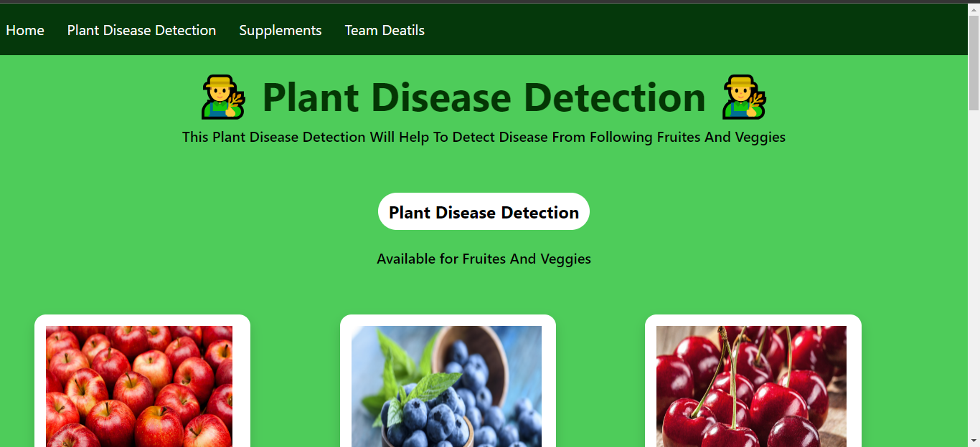

Figure 5.2: Leaf disease detection Homepage

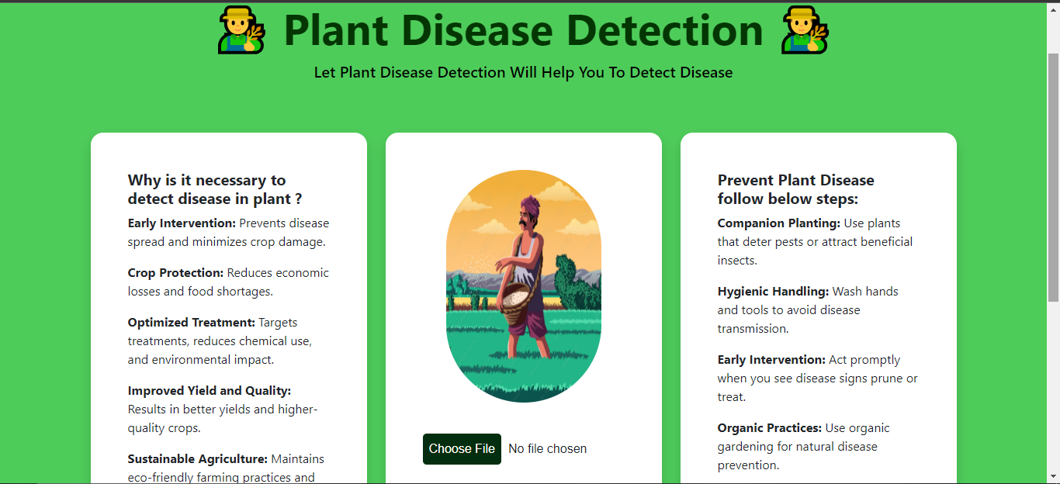

Figure 5.3: Leaf disease detection input page

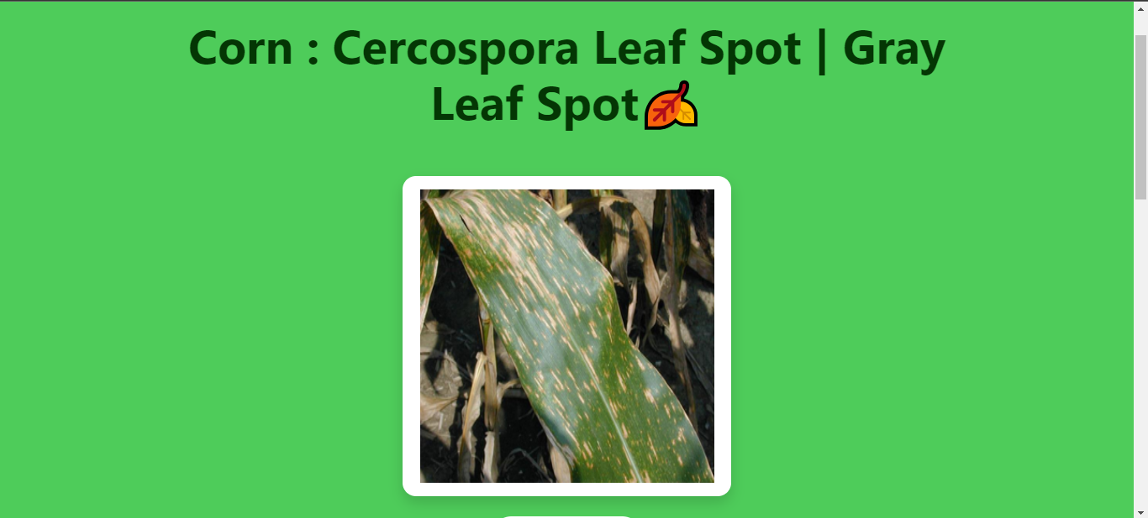

Figure : Leafdisease detectionresult page

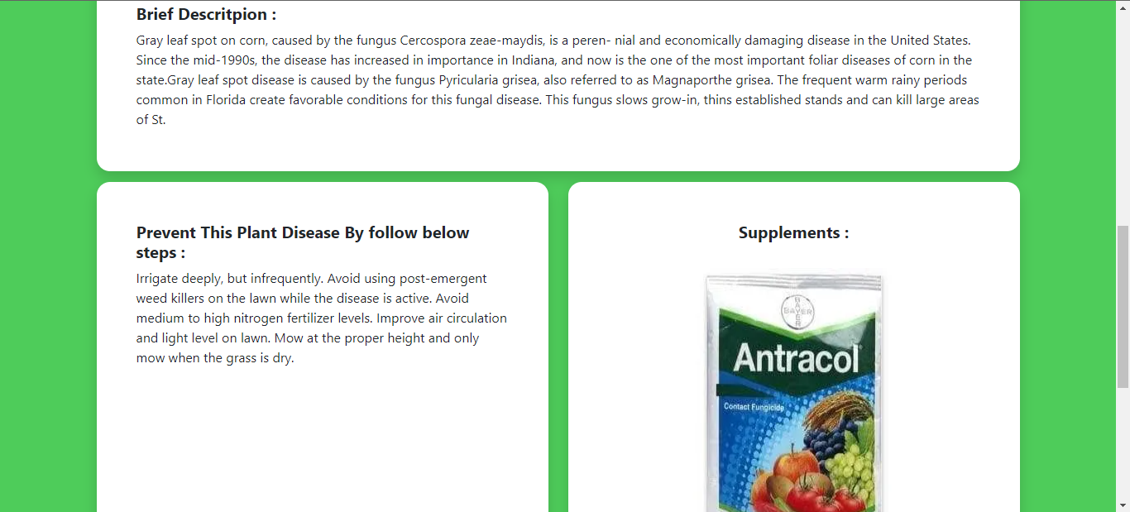

Figure: Leafdisease detectionresult description

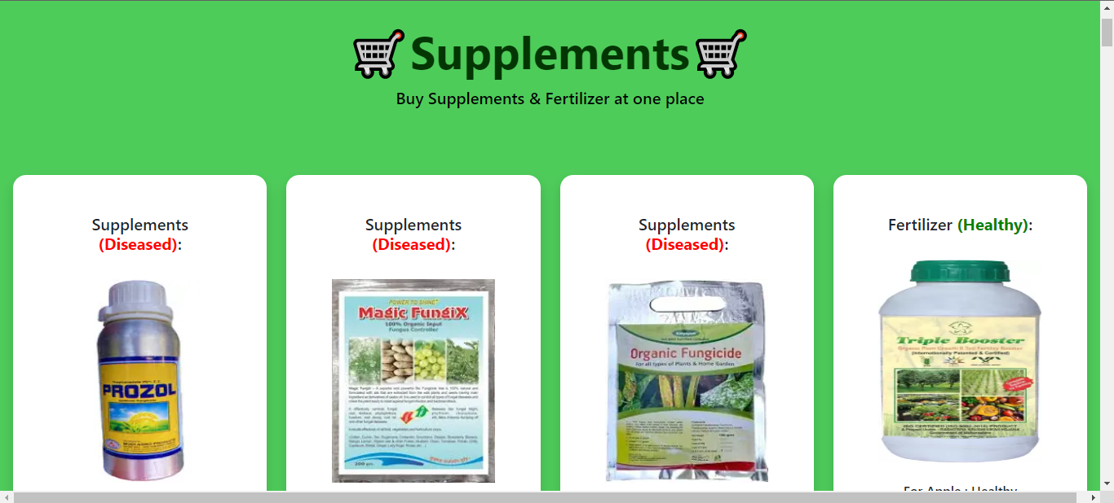

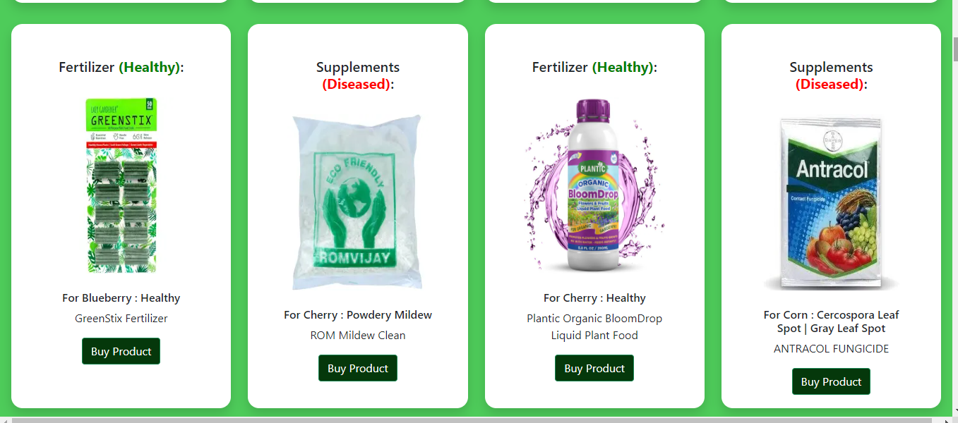

Figure: supplement page

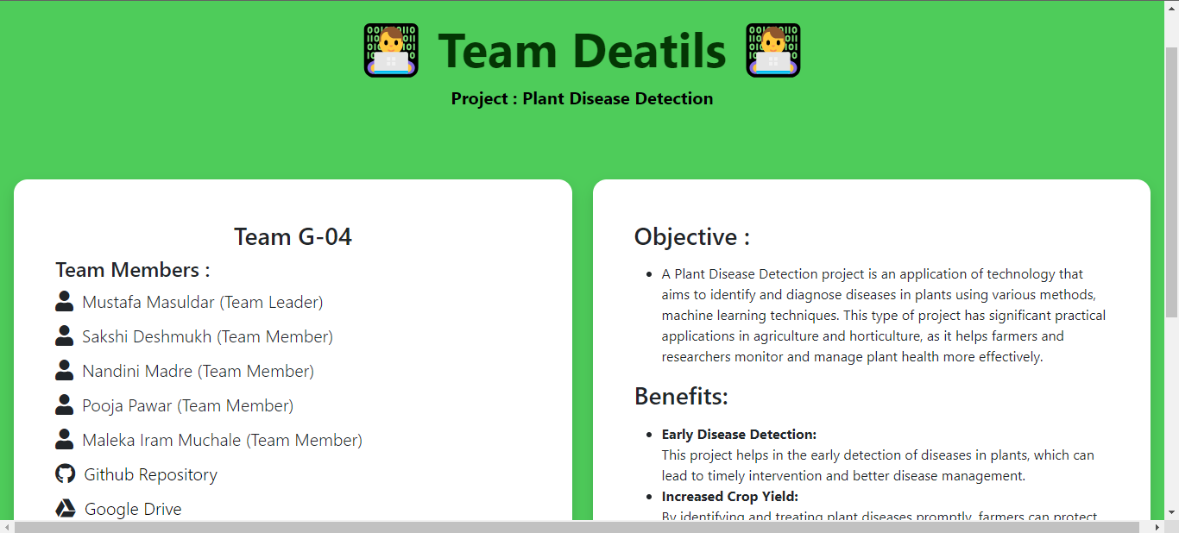

Figure: Team Details

**Dataset:**

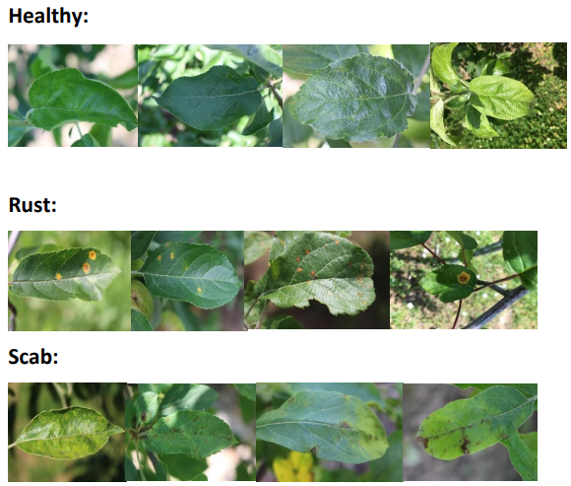

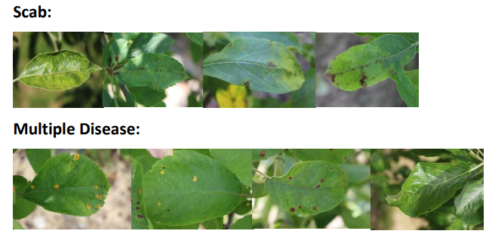

**Chapter 6**

**Testing**

Testing in software development is a crucial process of evaluating a software system or application to ensure that it meets the specified requirements and performs as expected. It involves executing various test cases and scenarios to identify defects, errors, or inconsistencies. Testing helps improve the quality and reliability of software by un- covering issues early in the development lifecycle. It encompasses activities such as test planning, test case creation, test execution, and defect reporting. Through systematic and rigorous testing, software developers can validate the functionality, performance, usability, security, and other critical aspects of the software to deliver a high-quality product to end-users.

**Test Plan**

The test plan aims to ensure the quality, functionality, and performance of the pro- posed solution for creating a consistent supply chain for biofuels using machine learn- ing, blockchain, Android application, MongoDB, and React. The plan outlines the approach, objectives, and key components of the testing process.

**Test Objectives:**

The primary objective of the proposed project is to implement a robust Plant Disease Detection system utilizing Convolutional Neural Networks (CNN). The aim is to leverage the power of deep learning to accurately and efficiently identify diseases affecting plants based on visual cues present in images of their leaves. By harnessing the capabilities of CNNs, which excel in discerning intricate patterns and features within images, the system seeks to enhance the precision of disease diagnosis.

The key goals include training the CNN model on a diverse dataset of plant images, encompassing various diseases and healthy conditions. Through this training process, the network is expected to learn distinctive features associated with different plant diseases. The ultimate objective is to develop a reliable and scalable solution that can contribute to early disease detection in plants, thereby aiding farmers and agricultural stakeholders in implementing timely interventions to mitigate crop losses and ensure food security.

**Testing Approach:**

**Unit Testing:**

In unit testing for the Plant Disease Detection system using Convolutional Neural Networks (CNN), individual components such as data preprocessing, the CNN model, and disease prediction are rigorously tested. This ensures the correctness and functionality of each unit, including the proper normalization and augmentation of input data, the accuracy of the CNN model in learning relevant features, and the precision of disease predictions against ground truth labels. Automated testing tools are employed to streamline the process, contributing to the overall reliability of the system in accurately identifying plant diseases.

**Integration Testing:**

The integration of the CNN model into the broader system is thoroughly examined to ensure it harmonizes effectively with the data preprocessing pipeline, contributing to accurate disease predictions. Additionally, integration testing assesses the interaction between the system and any external components, such as APIs or databases, ensuring smooth data exchange. By rigorously validating these integrations, the testing process aims to identify and rectify any potential issues that may arise from the collaboration of diverse components, ultimately ensuring the robustness and reliability of the entire Plant Disease Detection system.

**System Testing:**

System testing evaluates the overall functionality of the Plant Disease Detection system, verifying the integrated behavior of components like preprocessing, the CNN model, and the user interface. It ensures the accurate identification of plant diseases based on real-world inputs, addressing potential issues in the end-to-end functionality of the system.

**User Acceptance Testing**:

Plant Disease Detection system meets their requirements and expectations. It involves real-world testing scenarios to ensure the system aligns with user needs and operates effectively. UAT provides a final assurance that the system is ready for deployment and meets user satisfaction criteria

**Test Cases:**

Plant Disease Detection system. They serve as a roadmap for testing, outlining steps, expected outcomes, and criteria to validate that the system meets its requirements accurately and reliably.

**Test Execution and Reporting:**

Test execution involves running the defined test cases to assess the performance and functionality of the Plant Disease Detection system. Once executed, the testing outcomes are documented in a comprehensive report, highlighting successes, identified issues, and recommendations for improvement.

**Test Environment:**

The test environment refers to the specific setup and conditions where testing for the Plant Disease Detection system occurs. It includes hardware, software, network configurations, and other elements necessary to execute test cases accurately and simulate real-world conditions. Creating a well-defined and controlled test environment is essential for reliable and reproducible testing outcomes.

**Test Schedule and Resources:**

Test schedule and resources outline the timeline and personnel allocated for testing activities in the development of the Plant Disease Detection system. This includes assigning specific tasks, setting deadlines, and identifying the human and technical resources required to execute the testing process efficiently. A well-organized test schedule ensures timely completion of testing phases and successful project delivery.

**Risk Assessment:**

Risk assessment involves identifying, analyzing, and evaluating potential risks that may impact the successful development and deployment of the Plant Disease Detection system. It aims to proactively address uncertainties, allowing for the implementation of mitigation strategies to minimize the impact of identified risks.

By following this test plan, the proposed solution can undergo thorough testing to validate its functionality, performance, and usability. The test plan ensures that the system meets the defined objectives, adheres to requirements, and delivers a reliable and efficient biofuel supply chain solution.

# Functional Testing :

Functional testing is a quality assurance process that verifies if the Plant Disease Detection system's functionalities align with specified requirements. It involves testing features, user interactions, data manipulations, and system integrations to ensure that the application

**Non-Functional Testing**:

Non-functional testing assesses aspects of the Plant Disease Detection system eyond its functional capabilities. It focuses on qualities such as performance, reliability, usability, security, and scalability. This type of testing evaluates how well the system performs under various conditions and ensures it meets non-functional requirements to deliver a robust and user-friendly application.

**Performance Testing:**

Performance testing for the Plant Disease Detection system involves evaluating its responsiveness, stability, and scalability under different conditions. This testing phase assesses the system's ability to handle varying loads, process data within acceptable time frames, and maintain optimal performance levels.

**Usability Testing**:

This testing phase assesses how easily users can navigate the application, interpret information, and perform key tasks. Usability testing helps identify areas for improvement in terms of clarity, efficiency, and user satisfaction, ensuring that the system is intuitive and user-friendly. Feedback from real users is collected to enhance the design and functionality, ultimately optimizing the usability of the application.

**Security Testing:**

Security testing is a crucial process aimed at identifying and addressing potential vulnerabilities and weaknesses in the security mechanisms of the Plant Disease Detection system. This testing phase involves the systematic evaluation of the application's defenses against unauthorized access, data breaches, and other security threats.

**Compatibility Testing:**

By identifying and addressing compatibility issues, the system can reach a broader user base and maintain consistent performance across diverse platforms. Compatibility testing is essential for ensuring widespread accessibility and usability of the Plant Disease Detection application.

**Reliability Testing:**

Reliability testing focuses on the system’s ability to perform consistently and reliably over time. It involves testing for failure recovery, fault tolerance, error handling, and the system’s ability to recover from unexpected errors or crashes.

**Scalability Testing:**

Scalability testing assesses the system’s ability to handle increased workloads and to scale up or down as required. It ensures that the system can accommodate growth, handle increased user traffic, and maintain performance levels without significant degradation.

**Maintainability Testing:** Maintainability testing evaluates how easily the system can be maintained, enhanced, and supported. It focuses on factors such as code modularity, documentation, error logging, and ease of bug fixing or system up- dates.

**Compliance Testing:** Compliance testing ensures that the system adheres to applicable regulatory and industry-specific standards. It involves validating compliance with legal requirements, security regulations, data protection laws, and other relevant regulations.

Non-functional testing is essential to assess the overall quality and effectiveness of a system beyond its functional requirements. It ensures that the system meets user expectations, performs well under different conditions, remains secure, reliable, scalable, and adheres to applicable standards and regulation

**Chapter 7**

**CONCLUSION AND FUTURE SCOPE:**

**Conclusion:**

To prevent losses, small farmers are dependent on a timely and accurate crop disease diagnosis. In this study, Convolutional Neural Network will be used, and the model will be developed. The final result will be a plant disease detection desktop application. This service is free, easy to use. Thus, the user’s needs as defined in this paper have been fulfilled. A thorough investigation exposes the capabilities and limitations of the model. The achieved accuracy depends on a number of factors including the stage of disease, disease type, background data and object composition. Due to this, a set of user guidelines would be required for commercial use, to ensure the stated accuracy is delivered. As the model will be trained using a plain background and singular leaf, imitation of these features is best.

**Future Scope :**

Overall, we were able to understand how CNNs may be applied to empower small farmers in their fight against plant disease. In the future, work will be focused on diversifying training datasets for use in real life situations. Without such developments, the struggle against plant disease will continue.

**Appendix A**

**Appendix : List of Abbreviations**

ABBREVIATIONS ILLUSTRATION

* **ML:** Machine Learning
* **AI:** Artificial Intelligence
* **CV:** Computer Vision

.

# References:

1. S. Arivazhagan, R. Newlin Shebiah, S. Ananthi, S. Vishnu Varthini, “Detection of unhealthy region of plant leaves and classification of plant leaf diseases using texture feature”, CIGR, 2013, vol.15, no.1, pp.211-217.
2. Haiguang Wang, Guanlin Li, Zhanhong Ma, Xiaolong Li, “Image Recognition of Plant Diseases Based on Backpropagation Networks”, 5th International Congress on Image and Signal Processing (CISP 2012)
3. Bhange, M., Hingoliwala, H.A., ‘Smart Farming: Pomegranate Disease Detection Using Image Processing’, Second International Symposium on Computer Vision and the Internet, Volume 58, pp. 280-288, 2015
4. Pranali K. Kosamkar, Dr.V.Y.Kulkarni, Krushna Mantri, Shubham Rudrawar, Shubhan Salmpuria, Nishant Gadekar, ‘Leaf Disease Detection and Recommendation of Pesticides using Convolution Neural Network’, 2018 Fourth International Conference on Computing Communication Control and Automation (ICCUBEA)
5. Kaushik Kunal Singh, ‘An Artificial Intelligence and Cloud Based Collaborative Platform for Plant Disease Identification, Tracking and Forecasting for Farmers’, 2018 IEEE International Conference on Cloud Computing in Emerging Markets (CCEM)
6. Suma V, R Amog Shetty, Rishab F Tated, Sunku Rohan, Triveni S Pujar, ‘CNN based Leaf Disease Identification and Remedy Recommendation System’, Third International Conference on Electronics Communication and Aerospace Technology [ICECA 2019]
7. Marwan Adnan Jasim, Jamal Mustafa AL-Tuwaijari, “Plant Leaf Diseases Detection and Classification Using Image Processing and Deep Learning Techniques”, 2020 International Conference on Computer Science and Software Engineering (CSASE), Duhok, Kurdistan Region - Iraq